ShopEZ: One Stop Shop For Online Purchases

Team ID: LTVIP2025TMID20429

Date: 31 January 2025

# Data Flow Diagrams

A Data Flow Diagram (DFD) is a graphical representation of the flow of data through a system. It shows how data is processed by a system in terms of inputs and outputs. Below are two levels of DFDs for the ShopEZ e-commerce platform.

## Level 0 DFD - ShopEZ

The Level 0 DFD provides a high-level overview of the ShopEZ system, showing the major external entities, main processes, and data stores. It illustrates how a user interacts with the platform for actions such as registration, login, browsing products, placing orders, and receiving order confirmations.

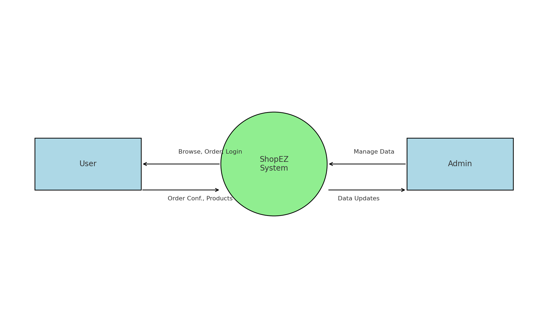

## Level 1 DFD - ShopEZ (User Registration and Order Flow)

The Level 1 DFD decomposes the user registration and order placement processes into more detailed steps. It includes interactions such as user credential validation, product catalog access, cart management, and order processing with confirmation.

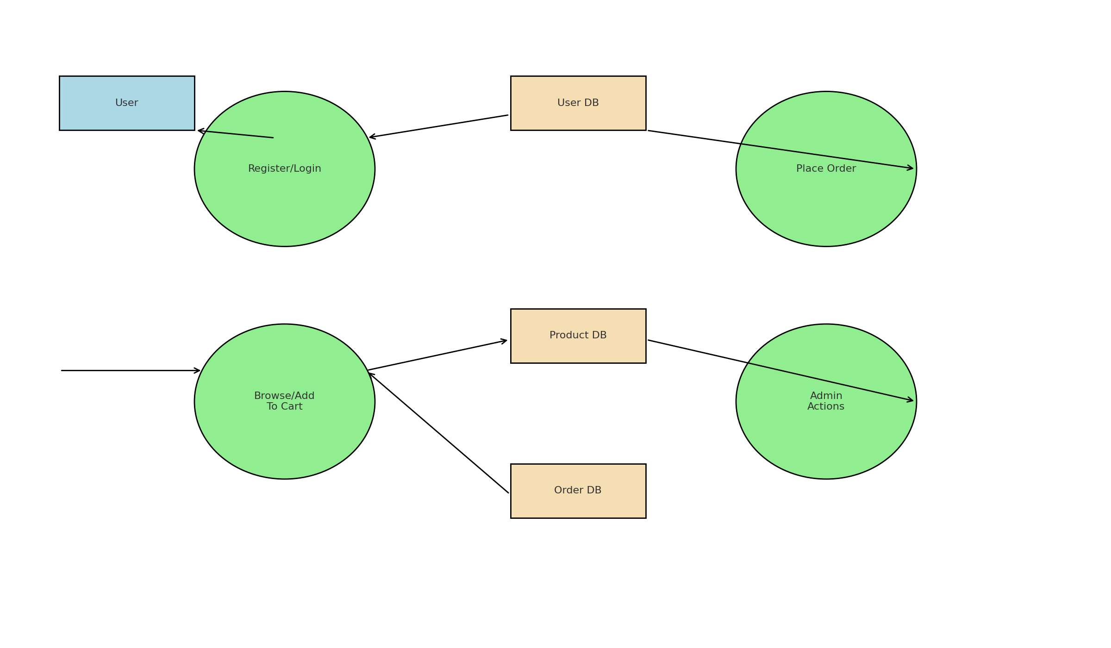

# User Stories

User stories describe features from the perspective of the end-user. They help developers understand the functional requirements and expected behavior of the application.

|  |  |  |  |  |  |
| --- | --- | --- | --- | --- | --- |
| User Type | User Story # | Functional Requirement | User Story / Task | Acceptance Criteria | Priority |
| Customer (Mobile) | USN-1 | Registration | As a user, I can register using email, password, and confirm password. | User can access dashboard after registration. | High |
| Customer (Mobile) | USN-2 | Registration | As a user, I will receive a confirmation email after registration. | User receives confirmation email and clicks to verify. | High |
| Customer (Mobile) | USN-3 | Registration | As a user, I can register through Facebook. | User can log in with Facebook. | Low |
| Customer (Mobile) | USN-4 | Registration | As a user, I can register through Gmail. | User can log in with Gmail. | Medium |
| Customer (Mobile) | USN-5 | Login | As a user, I can log in using email and password. | User can access their profile page. | High |
| Customer (Mobile) | USN-6 | Shopping | As a user, I can browse and filter products. | Filtered products are displayed. | High |
| Customer (Mobile) | USN-7 | Cart | As a user, I can add items to the cart. | Items are added and visible in cart. | High |
| Customer (Mobile) | USN-8 | Order | As a user, I can place an order with payment and address. | Order is confirmed with summary. | High |
| Administrator | USN-9 | Admin Dashboard | As an admin, I can manage product listings. | Admin can add/edit/delete products. | High |
| Administrator | USN-10 | User Management | As an admin, I can view registered users. | Admin sees the user list. | Medium |